1. **Interpret the residual**

The student gets 44 points on his exam. Find and **interpret** our model’s prediction error (residual) for this student.

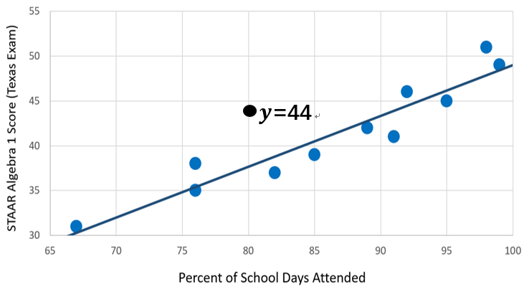

1. **Residual Plot**

* **Def:**
* **Why residual plots?**

**It allows us to see**

1. **Standard deviation of residuals (s)**

* **Def:**

* **Interpret the value of s**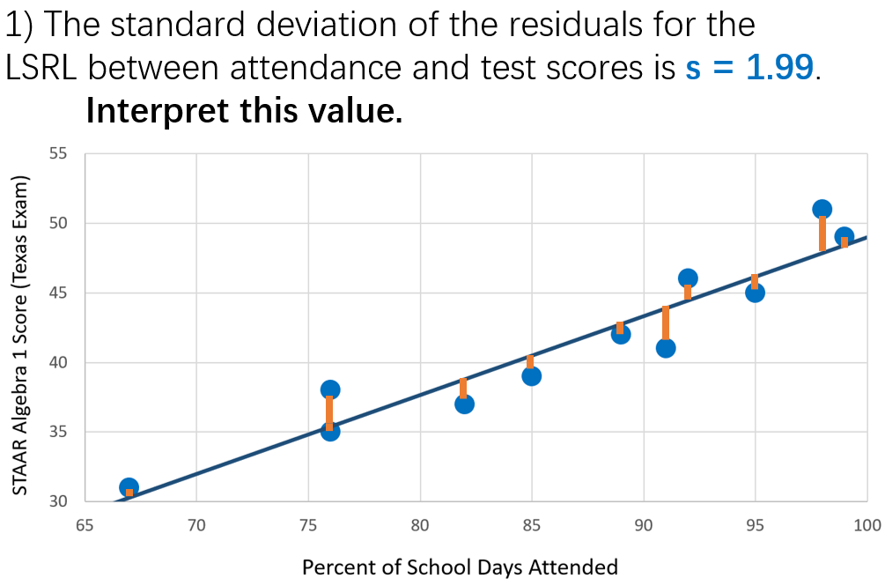

1. **The coefficient of determination**

* **Why R square?**

* **Interpret the R square:**